Calendar.html test result

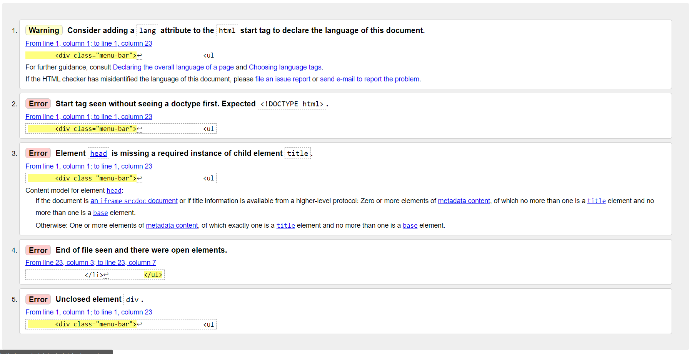

Enviroment.html test result

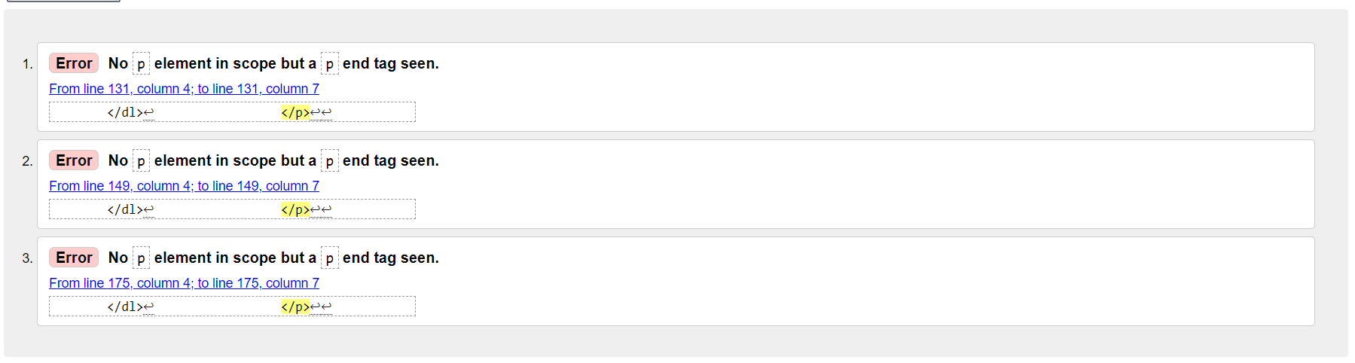

Hotels.html test result

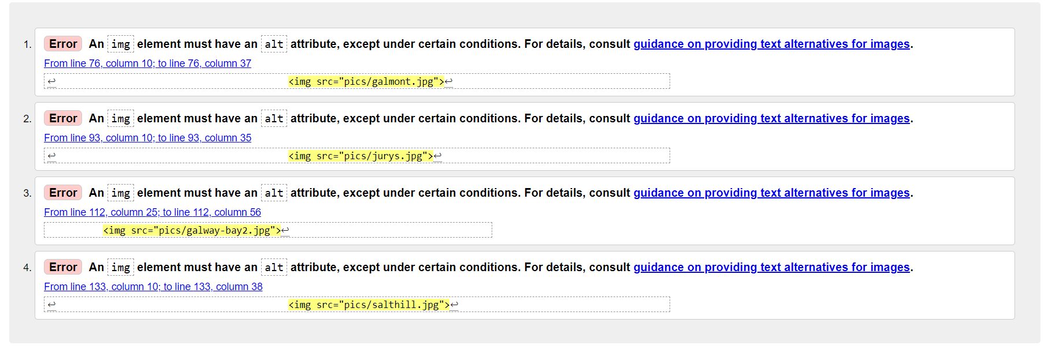

Index .html test result



Restauraunts.html test result

